Objective: To create awareness of entry point hazards in commercial, retail, and residential buildings, improving employee safety

Entrance Mat Length Criteria in Various Weather
Dry: 6 – 8 Steps
Rain: 8 – 10 Steps
Snow: 10 – 12 Steps

Causes of Entry Hazards
- Entrants tracking in water or contaminants from outside
- A change in floor surfaces that reduces traction
- An uneven entrance mat
- Entrants being focused on where they are going next rather than looking for hazards
These causes can lead to slips, trips, and falls, which can result in severe injuries. However, these incidents are preventable by taking precautions.
Employee Responsibilities
- Take responsibility. If you see a hazard, report it and assure that it is corrected, rather than leaving it.
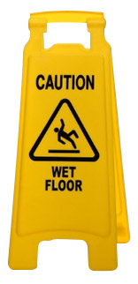
- Make sure controls are in place. Entry points require certain controls, such as absorbent mats of sufficient length, signs, and/or attendants.
- Perform any needed housekeeping. Do not allow clutter to accumulate.
- Use “wet floor” signs as needed.
Employer Responsibilities
- Providing mats for entryways and securing them
- Maintaining floors
- Assuring that regular inspections are performed
This form documents that the training specified above was presented to the listed participants. By signing below, each participant acknowledges receiving this training.

Organization: Date:

Trainer: Trainer’s Signature:

Class Participants:

Name: Signature:

Name: Signature:

Name: Signature:

Name: Signature:

Name: Signature:

Name: Signature:

Name: Signature:

Name: Signature:

Name: Signature:

Name: Signature:

Name: Signature:

Name: Signature:

Name: Signature:

Name: Signature:

Name: Signature:

Name: Signature:

Remember to document attendance in the Training Track application of the Risk Management Center.

