Objective: To familiarize employees with common types of hand protection and best practices for their use

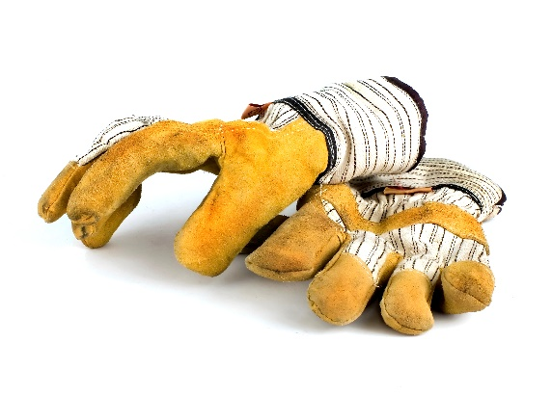
Your hands can be subject to numerous potential injuries at work, especially when working with chemicals, extreme hot or cold temperatures, and sharp, heavy, or abrasive objects and surfaces.
Make sure you use the appropriate level of hand protection to minimize the chance a hand injury.
Glove Types
Protective gloves are available in a variety of materials that protect against various hazards.
Material | Protects Against
Latex, butyl, nitrile, neoprene, synthetics | Chemical burns, biological hazards, irritation, and dermatitis
Metal mesh, leather, canvas | Cuts, abrasions, punctures, and burns
Fabric and fabric-coated | Dirt and abrasions
Rubber | Cuts, punctures, and abrasions
Insulated | Extreme heat or cold

Selection Criteria
When selecting gloves, consider the following:
- What tasks are being performed
- Conditions in the work area
- Duration and frequency of use
- Grip and manual dexterity needed
- Puncture and cut resistance needed
- Chemical resistance
- All other potential hazards
Safe Practices
- Prior to each use, inspect gloves for:
  - Holes or other signs of wear.
  - Discoloration or stiffness resulting from manufacturing flaws.
- If using disposable gloves, verify they have not been previously worn before use.
- Do not use gloves that show defects or excessive wear. Replace defective or excessively worn gloves as needed.
- When work is complete, take appropriate precautions when removing gloves to avoid exposure to hazardous materials.
  - When appropriate, wash gloved hands before removing gloves.
  - Pull the gloves’ cuffs over your hand to remove inside-out.
- Store or dispose of gloves properly after each use.
- Wash your hands after disposing of gloves.

This form documents that the training specified above was presented to the listed participants. By signing below, each participant acknowledges receiving this training.

Organization: Date:

Trainer: Trainer’s Signature:

Class Participants:

Name: Signature:

Name: Signature:

Name: Signature:

Name: Signature:

Name: Signature:

Name: Signature:

Name: Signature:

Name: Signature:

Name: Signature:

Name: Signature:

Name: Signature:

Name: Signature:

Name: Signature:

Name: Signature:

Name: Signature:

Name: Signature:

Remember to document attendance in the Training Track application of the Risk Management Center.

