Objective: To provide an overview of potential eye hazards and safe practices for using eye protection

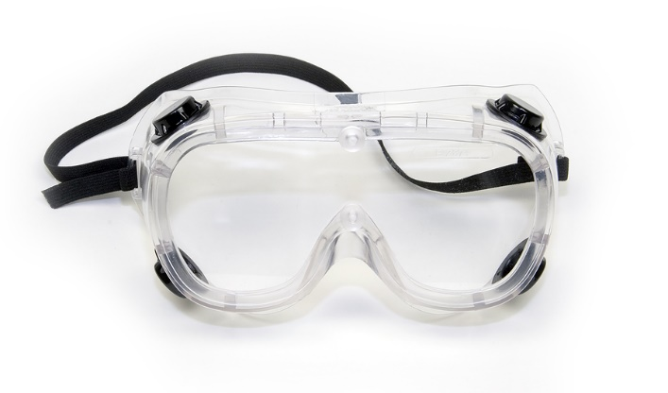
The Importance of Eye Protection
The majority of work-related eye injuries are a result of flying or falling objects or sparks striking the eye.
Other common potential hazards include the following:
- Fumes
- Vapors
- Chemical splashes
- Extremely bright or hazardous light, such as from welding
Common Types of Eye Protection
A job hazard assessment performed prior to the start of a particular task will determine the type of eye protection required.
- Safety glasses are a common form of protection against low-to-moderate impacts and sparks from activities such as grinding and woodworking. Only use safety glasses with side shields.
- Goggles form a protective seal around the eye area to better protect from hazardous chemical vapors, splashes, or dust or other small particles that may enter the eye. Make sure that your goggles include ventilation mechanisms to prevent fogging.
- Face shields provide protection for the entire face against flying particles, sparks, splashes, harmful mists, and other hazards.
- Welding masks are specially designed to protect from radiant energy, sparks, and metal splatters from welding.
Proper Use
- Always wear proper eye protection where required, even if danger to your eyes seems remote.
- Before use, verify that your equipment is appropriate for the task.
- Inspect eye protection prior to each use.
- If you wear prescription eyewear, use eye protection that accommodates it. Prescription eyewear by itself is not a substitute for safety glasses or goggles.
- When welding or cutting, always wear safety glasses or goggles underneath face shields or welding helmets.
- When your work is complete, store eye protection properly and away from extreme temperatures or direct sunlight.

This form documents that the training specified above was presented to the listed participants. By signing below, each participant acknowledges receiving this training.

Organization: Date:

Trainer: Trainer’s Signature:

Class Participants:

Name: Signature:

Name: Signature:

Name: Signature:

Name: Signature:

Name: Signature:

Name: Signature:

Name: Signature:

Name: Signature:

Name: Signature:

Name: Signature:

Name: Signature:

Name: Signature:

Name: Signature:

Name: Signature:

Name: Signature:

Name: Signature:

