Objective: To create awareness of the accident prevention pyramid and steps which can be taken to address unsafe acts and conditions before they lead to incidents, severe injuries, and even fatalities

Most accidents in the workplace involve both unsafe conditions, such as inadequate ventilation or improper storage of hazardous materials, and unsafe actions, such as bypassing controls or failing to wear personal protective equipment (PPE).
Unsafe acts and conditions lead to progressively more serious injuries and even fatalities. Organizations must work to eliminate both unsafe conditions and unsafe actions in order to bring down these other numbers.
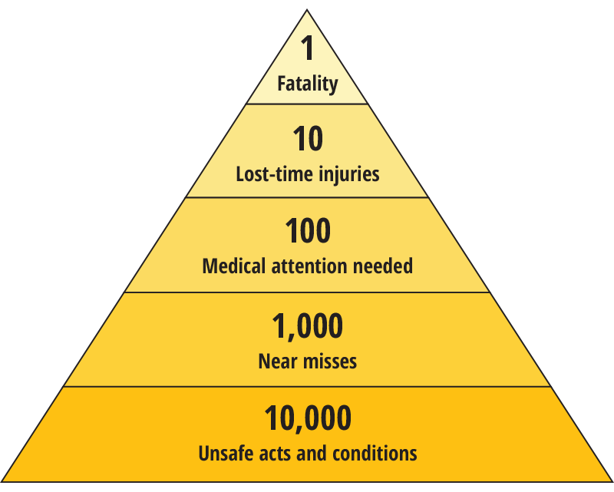

Addressing Unsafe Conditions
- Unsafe conditions should be discovered by hazard assessments, including job hazard analyses (JHAs).
- Ideally, hazards should be completely eliminated or substituted with safer options. If this is not possible, hazards should be managed with engineering controls, administrative controls, and PPE (PPE should be considered as a last resort).
- Conditions should be monitored with regular inspections, audits, and safety observations.
Addressing Unsafe Actions
- Organizations must coach and train employees in safe behaviors.
- Organizations must also develop a good safety culture by getting all employees and all levels of management involved in the safety program.
- The organization must be very clear with safety priorities. Management and supervisors must lead by example.
- Regular inspections, audits, and safety observations should also note employee behaviors and their understanding of safety procedures.
- Safe behaviors should be rewarded and reinforced.
- Discipline should be utilized as a last resort.

This form documents that the training specified above was presented to the listed participants. By signing below, each participant acknowledges receiving this training.

Organization: Date:

Trainer: Trainer’s Signature:

Class Participants:

Name: Signature:

Name: Signature:

Name: Signature:

Name: Signature:

Name: Signature:

Name: Signature:

Name: Signature:

Name: Signature:

Name: Signature:

Name: Signature:

Name: Signature:

Name: Signature:

Name: Signature:

Name: Signature:

Name: Signature:

