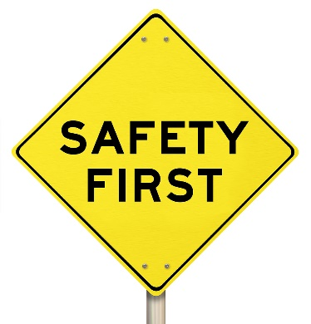
“Accident prevention is everyone’s responsibility.”
You have probably heard the above TRUE statement more times than you can remember! Safety has to be the responsibility of every one of us. No one person can constantly watch, guide, and instruct every operation every day.
Our organization’s management team is very concerned with your safety. However, no one person is more important than you when it comes to doing your job in a safe manner.
You should know how to do your job safely which requires a level of risk awareness beyond your immediate task. The training that you have received, the established work procedures, the general safety rules, and the use of common sense all provide the basis for you and your co-workers to go home after work healthy and free of injuries… and that is very important to everyone.
As an employee of _______________, you are responsible for:
- Asking questions related to task/job hazards and the safety controls designed to reduce or eliminate their occurrence or impact.
- Ensuring you have the proper PPE as defined by task/operation-specific hazard analysis and that it is working order.
- Ensuring all required training is completed within the mandated timeline.
- Abide by all company safety policies and procedures and questioning the same where misunderstanding may result in a loss event.
- Preventing or halting co-workers from engaging in at-risk behaviors through active and passive observation and awareness.
- Actively participating in safety awareness initiatives and committees.
Please remember: Your responsibility for safety and accident prevention does not stop when you leave the jobsite. At home, behind the steering wheel, even when on vacation, you need to keep a watchful eye on safety. Not just for your own well-being, but also for the well-being of those you care about.
This form documents that the training specified above was presented to the listed participants. By signing below, each participant acknowledges receiving this training.

Organization: Date:

Trainer: Trainer’s Signature:

Class Participants:

Name: Signature:

Name: Signature:

Name: Signature:

Name: Signature:

Name: Signature:

Name: Signature:

Name: Signature:

Name: Signature:

Name: Signature:

Name: Signature:

Name: Signature:

Name: Signature:

Name: Signature:

Name: Signature:

Name: Signature:

Name: Signature:

