Personal commitments you can live and work by:

- I anticipate possible dangers in any given operation and make every effort to analyze and avoid them before starting work, including immediately communicating such to my direct report.

- I am careful when using tools and use them only for the purpose for which they were designed. I look for defects. If I discover a defective tool I will turn it in for repair or replacement.

- At all times, I practice good housekeeping habits. I believe in the policy of a place for everything and everything in its place.

- I understand the importance of participating in company training, standard practice development, job hazard assessments and incident investigations to further enhance overall safety.

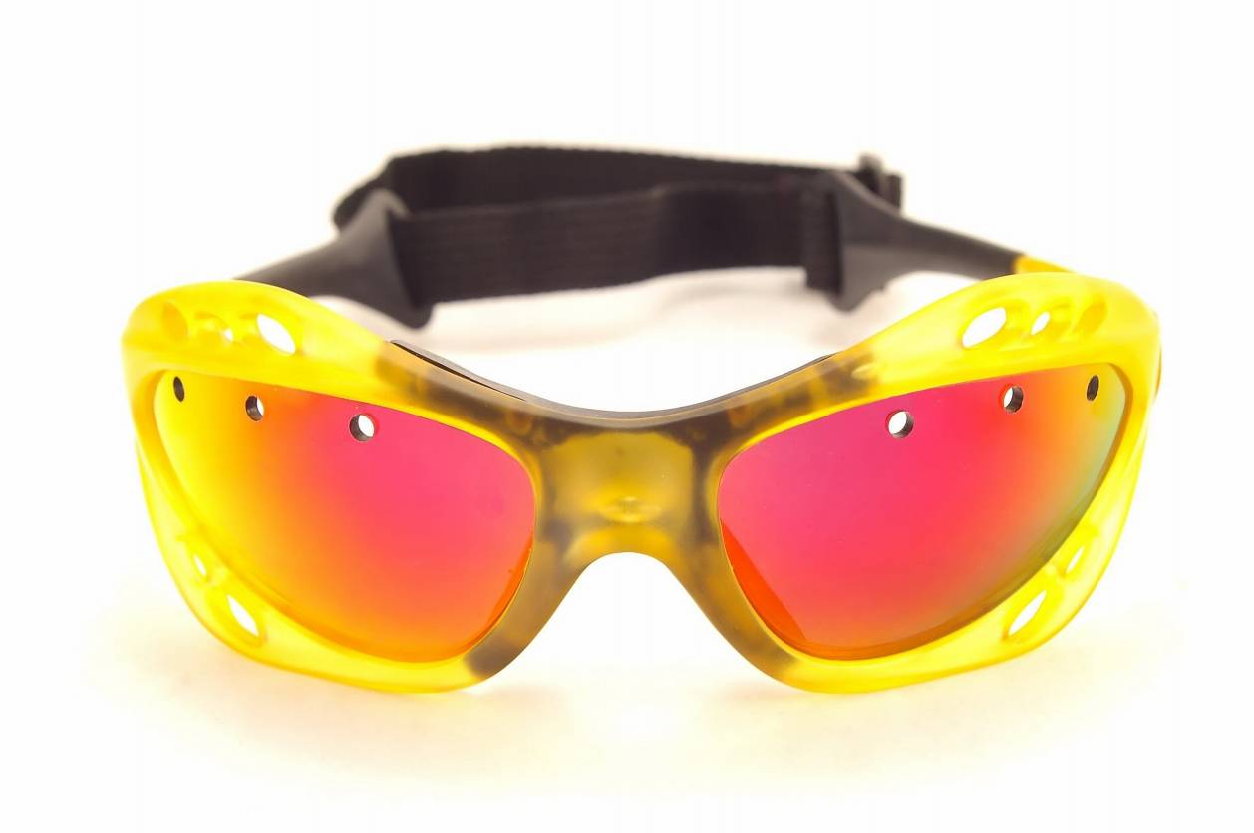
- When operating machinery, I follow all machine specific training and requirements, recognize the hazards involved and take necessary precautionary measures. Before starting a piece of equipment, I look it over to ensure that neither workers nor materials will be endangered. When I leave equipment unattended, I make certain that it is safely shut down. I take necessary precautions to prevent the equipment from being started by an unauthorized person.

- While driving, I obey all traffic rules and regulations. I am alert to the possible inadequacies of other drivers and am prepared to make necessary allowances for safety on the road.

- I take the necessary precautions to properly attend to cuts and scratches. I am aware that by doing this, I can avoid potential infections.

- I believe in wearing personal protective equipment (PPE). I am fully aware of the many times in the past when using PPE, such as safety glasses, safety shoes and gloves, has enabled workers to avoid injury.

This form documents that the training specified above was presented to the listed participants. By signing below, each participant acknowledges receiving this training.

Organization: Date:

Trainer: Trainer’s Signature:

Class Participants:

Name: Signature:

Name: Signature:

Name: Signature:

Name: Signature:

Name: Signature:

Name: Signature:

Name: Signature:

Name: Signature:

Name: Signature:

Name: Signature:

Name: Signature:

Name: Signature:

Name: Signature:

Name: Signature:

Name: Signature:

Name: Signature:

